Meeting
dinsdag 9 februari 2016
11:50

Meeting Date: 8-2-2016 10:00
Location: KNT.T02.04
Link to Outlook Item: click here
Invitation Message
Participants
Lennard de Ridder 201588153 (Meeting Organizer)

Notes
Contact manager
Phone president
Make OneNote assignment

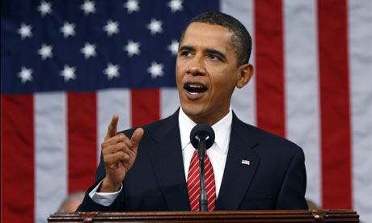

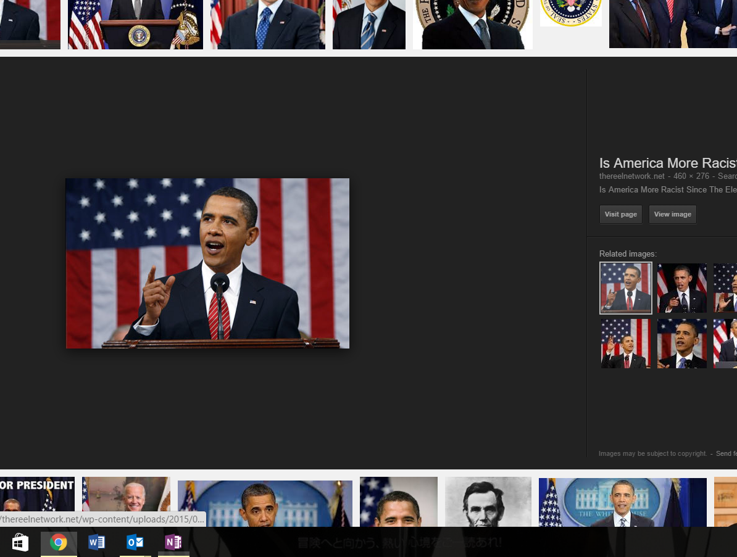

9-2-2016 11:53 - Screen Clipping

Microsoft Corporation /ˈmaɪkrəˌsɒft, -roʊ-, -ˌsɔːft/^{[5][6]} (commonly referred to as Microsoft) is an American multinational technology company headquartered in Redmond, Washington, that develops, manufactures, licenses, supports and sells computer software, consumer electronics and personal computers and services. Its best known software products are the Microsoft Windows line of operating systems,Microsoft Office office suite, and Internet Explorer and Edge web browsers. Its flagship hardware products are the Xbox game consoles and the Microsoft Surface tablet lineup. It is the world's largest software maker by revenue,^{[7]} and one of the world's most valuable companies.^{[8]}
Microsoft was founded by Paul Allen and Bill Gates on April 4, 1975, to develop and sell BASIC interpreters for Altair 8800. It rose to dominate the personal computer operating system market with MS-DOS in the mid-1980s, followed by Microsoft Windows. The company's 1986 initial public offering, and subsequent rise in its share price, created three billionaires and an estimated 12,000 millionaires among Microsoft employees. Since the 1990s, it has increasingly diversified from the operating system market and has made a number of corporate acquisitions. In May 2011, Microsoft acquired Skype Technologies for $8.5 billion in its largest acquisition to date.^{[9]}
As of 2015, Microsoft is market dominant in both the IBM PC-compatible operating system (while it lost the majority of the overall operating system market to Android) and office software suite markets (the latter with Microsoft Office). The company also produces a wide range of other software for desktops and servers, and is active in areas including Internet search (with Bing), the video game industry (with the Xbox, Xbox 360 and Xbox One consoles), the digital services market (through MSN), and mobile phones (via the operating systems of Nokia's former phones^{[10]} and Windows Phone OS). In June 2012, Microsoft entered the personal computer production market for the first time, with the launch of the Microsoft Surface, a line of tablet computers.
With the acquisition of Nokia's devices and services division to form Microsoft Mobile Oy, the company re-entered the smartphone hardware market, after its previous attempt, Microsoft Kin, which resulted from their acquisition of Danger Inc.^{[11]}
Microsoft is a portmanteau of the words microcomputer and software.^{[12]}

From <https://en.wikipedia.org/wiki/Microsoft>

Hand in assignment

<<Meeting.wma>>

Audio recording started: 11:55 dinsdag 9 februari 2016

Audio recording started: 11:55 dinsdag 9 februari 2016

