Task 1B

Report Flowkey

Flowkey was founded by Jonas Gößling after he found out that there was no such platform available as Flowkey. Flowkey offers people the option to learn how to play the piano online. There are instruction videos on YouTube, but FlowKey has a software available which can recognise which notes you play. This enables the user to learn to play way quicker, as if you were taught by a real-life teacher. The people who play the piano are real-life people, of course, and they are top class musicians. They play the songs, which the user has to play along to.

Jonas Gößling started from his University, who was very helpful. They gave him his first financial support, but he was looking for business angels and other investors at the same time. His University brought him into contact with a business angel and he gave him the resources he needed to get his company up and running. The platform itself is not online for such a long time, but the beta version existed for quite a while already. The funding were needed primarily for starting up the application. He also got support from the local government in Berlin.

After this financial injection, the ball started rolling and once he had his platform up to the standard he wanted, he launched it. Via other contacts, he got in touch with Yamaha. This enabled him to reach a larger audience. At the moment of the interview, he had 1,000,000 users of his application. Of course, these are not all paying users, but he was seeing an incline in paying users and therefore revenue. He did not want to share the exact details.

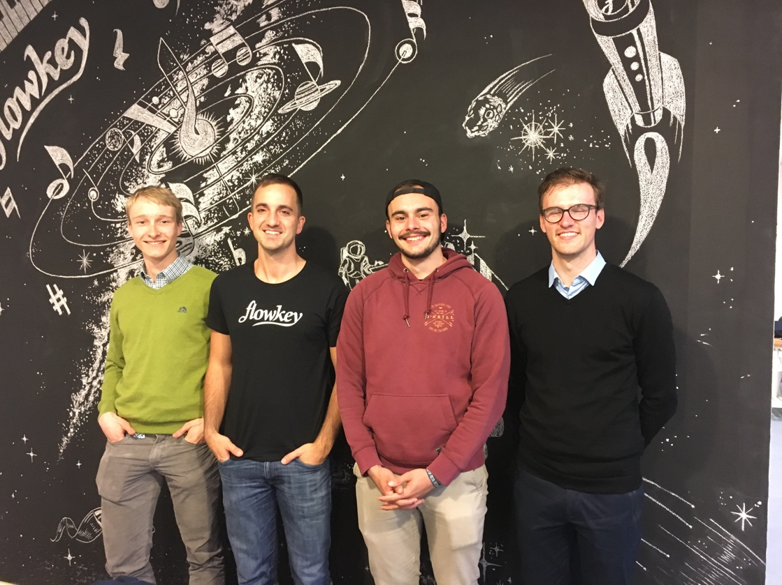
A tip he gave to us was, if you pursue a dream to start up your own company, focus on setting up the company only. All the rest should come at a second place, but of course until a healthy balance. He also told us that the financial injections he received were very helpful, but that he would have gotten where he is now in another way as well. You do have to keep your goal clearly in your mind and pursue it. He was working for about 4 years on the idea and setting up the company alone.

