Date and timing | Description of the activity | Participants | Short evaluation and personal reflection | Photo in action
14-12-2016 | Christmas market in Ghent (cultural activity) | Cedric, Maximiliaan, Yasmine, Lennard | We had a stroll over the Christmas market in Ghent and watched Ghent being illuminated and saw it showing its architectural beauty | 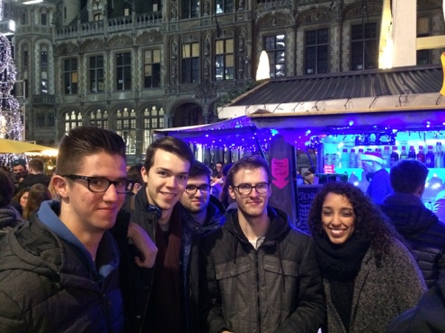
Throughout semester 1 and 2 | Tutoring via Facebook and on the event + when we met the buddies in the hall way/ canteen etc | Most of these sessions were with Cedric, some with Maximiliaan | Cedric was really open for feedback and asked us questions, Maximiliaan did not respond most of the time. | No photos taken
29-3-2017 | Mentor-mentee super bowling event | Cedric was in the hospital, Maximiliaan was coming but did not in the end, Lennard and Yasmine were the only ones | I sent you an email containing the complaints of Yasmine and me the evening of the ‘failed’ organised event. Cedric gave us a heads-up in advance, so he cannot be blamed | Because of the ‘fail’, we do not have a picture.

Reflection:
Our mentees were two totally different persons. Cedric was the kind, easy-going guy, while Maximiliaan thought he could handle the entire world already. Cedric responded within minutes after we sent him a question, while Max would wait quite a while before responding.
We believe that the mentees did like the Christmas market the most, as it was not really school-related, although they could ask their questions of course. I think that the feedback we gave them during the semesters via Facebook or face-to-face in the hall ways and canteen benefited them the most. I supplied them with my summaries and assignments of last year and told them about the exams and best ways to study.
What I found really difficult is keeping the mentees motivated to join you in going on obligatory ‘trips and tasks’. I think that if you make a mentorship a voluntary choice, you will have full cooperation from both sides.
I did like the fact that I could help our mentees to have a head start and to give them an idea of what they could expect. Of course, we have already done everything they are doing now, so for us it is not really a big effort to help them out. In activating our mentees, I think both Yasmin and I succeeded, but unfortunately, Max was a disturbing factor, as he told us he would be there, but in the end he cancelled at the very last moment. At the bowling event, he even cancelled a quarter after we would supposedly start. These are some issues we could not have foreseen, without coming across as totalitarian rulers, so I contacted you as my ‘manager’. Cedric on the other hand was really enthusiastic about all the activities and it is a pity that he could not go with us to the bowling event. I spoke to him in the hall way recently and he had used all the tips I gave him before, which sort of makes me proud.

