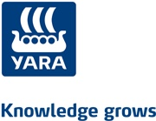
Management Observation International Manager
Jon Sletten: General Director YARA Sluiskil

YARA
When you think of artificial fertilizer, you should immediately think of YARA. This Norwegian company dates from as early as 1905. It was then called Norsk Hydro and was founded by three men, who all contributed in another part, necessary to found a factory like Norsk Hydro: Eyde, who brought the vision, Birkeland the science, and Wallenberg the capital.
YARA International is a company specialised in fertilizer and products for environmental protective and industrial applications. The Head Quarters are in Oslo, but YARA is represented in every continent in the world. YARA Sluiskil is an example for the other factories, because they produce fertilizers to make farmers able to produce an extra needed 70% of food, due to world population growth. While producing, they are very much aware of how they produce it. The three ammonia plants of YARA Sluiskil belong to the the most energy efficient factories of the entire world. They also limit the factory gasses like N2O drastically to a bare minimum. The technologies used are world leading.
YARA Sluiskil is very much focused on being a good neighbour. This means that they take into account the noise level, emissions (as a part of the environment), but also local labour participation. YARA Sluiskil has about 600 employees, which makes it one of the largest employers in Zeeuws-Vlaanderen and by extend Zeeland. A good example of the things YARA does for the environment is the rest warmth which is transferred to the green houses located a few kilometres further. The warmth and CO2 are used for their process and therefore makes it the most durable green house area of the Netherlands. The government has many rules for chemical companies, but YARA is producing almost on the theoretical limit of emissions.

Function of manager
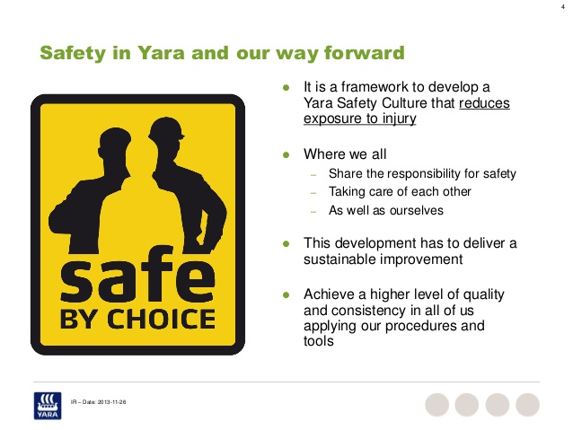
Mr Jon Sletten is the General Director of YARA Sluiskil. He is responsible for all the 604 employees. I have attached an organogram at the very end of this paper. His tasks are mainly to make sure all the teams are instructed properly to instruct their teams on their turn. This is all done in order to make the factory as efficient, but safe at the same time. Safe by choice is a very important issue on the plant, if not the most important. Mr Sletten focuses on this very much himself as well. Nobody is allowed to enter the plant without a helmet, safety glasses and protective clothing.

Agenda
08:00 Meeting about proposal
09:00 Review meeting December
11:00 Steering Committee stop Ammoniac
12:30 Lunch
13:00 Meeting with the Board / Tour around the plant
14:00 HESQ meeting
Meeting about proposal
This meeting was about a company which is trying to centralise all the activities related to recruiting people to work or study in a technical area. When the costs of their new plan are lower, or if they can give more for the current price, then there is a possibility that they receive support. Mr Sletten has end responsibility in this question and asked questions related to the content of the proposal, as well to the costs.
Review meeting December
The figures of December were presented to Mr Sletten, as well as to the vice-director and some other members of the three production departments. Their presentation was very detailed and gave a good overview of how they performed. I am not going into details here, because this was very confidential information.
Steering Committee stop Ammonia
This meeting was about a stop of the Ammoniac factory which is going to take place in the end of this year. The costs of such a stop can get very high, which is why they have to think about it on beforehand. Mr Sletten is member of the Steering Committee. Some other managers who were present were the turnaround manager, purchasing manager, HESQ manager, production manager Ammonia, local maintenance manager Ammonia, technical process owner maintenance (upstream) and the technical process owner Ammonia (Upstream)In this meeting a lot of figures were discussed, but once again I cannot and will not say anything about this. However, it was a good thing the meeting took place, so everyone knew how far the responsible persons were in the process.
At 12:30 we had lunch in the canteen of the factory.
Meeting with the Works Council/ Tour around the plant
At 13:00, Mr Sletten had a meeting with the Works Council. I could not take part here, because confidential matters were discussed here, that cannot be heard by outsiders. However, he had arranged a tour around the plant with a potential client for me, which was also very nice. The tour guide (public relations officer) also pointed out the things YARA does for the environment. For example, in one of the factories, a hawk is breeding, which they try to keep it that way and even monitor it using cameras. Also, a part of unused ground is given back to the nature, which lead to several foxes living on the plant and all kinds of other species. They have also created a pasture for people to go and have a picnic or relax in the summer.
HESQ meeting
At 14:00 I attended a HESQ (Health Environment Safety and Quality) meeting. Already in the name of this board you can see the values that YARA holds high are represented. Mr Sletten was a bit later because of the meeting with the board. In this meeting they spoke a lot about how these four factors could be controlled more. Again, safety is probably the most important one. I cannot tell the details of the meeting.

Interview
Mr Jon Sletten was 32 when he first became manager. This was in the function of production manager. In 2011 he first became plant manager, but this was in Sweden. A year after that he became General Director of YARA Sluiskil. When I asked him what he thought of his age when becoming manager, he made a very nice remark. He said that he was fortunate enough to start in a small production department as production manager. After all, becoming a manager is also a lot of ‘learning by doing’.
The four key words of YARA really come back in how Mr Sletten wants to be perceived as a manager. YARA focuses on Teamwork, Trust, Ambition and Responsibility. Mr Sletten wants to be perceived as open and honest and believes in getting to the right direction together as a team. Together you have to come to a solution. If this is not possible, the discussion which follows should lead to the right direction.
The General Director is ‘of course not’ always right. Everyone makes mistakes and Mr Sletten will definitely admit it when he has made a mistake. However, sometimes decisions have to be made and that is not always nice to do, but it is part of the job and it makes the company able to move forward. He really believes in focusing on the mutual idea in stead of the different ideas. This creates cooperation and appreciation.
Mr Sletten also tries to motivate his teams all the time. When it still happens that someone is absolutely not willing to cooperate, he will talk to the specific persons and ask him why he is not doing his job well and tries to solve the problem. In 98% of the cases this helps. When employers on a lower level experience problems, their superior is first in line to help them.
Mr. Sletten spends about 60 hours a week on his job. He leaves his home at 07:30 and usually returns at 18:00. At home he has to spend approximately an hour a day on his job and some work in the weekends as well. If you organise and delegate your tasks in a professional way, it is really doable. Also, when in a reorganisation he would acquire more tasks, he would still be able to be able to live up to his expectations. Every challenge requires a solution. The biggest challenge is to find the right focus between intern and extern jobs. He believes it is of major importance to walk around on the plant, it is very much appreciated by his employees, because he shows them that he really is interested and is not locked up in an ivory tower.
The hierarchy in YARA International gives him sometimes enough space to breathe and sometimes too little. In some cases, he is too limited in what he can do, but for the majority of tasks he gets a green light to do as he thinks works best. He has no ambition (yet) to get a higher function, because he has the best function within YARA he could wish for. However, this function is not forever, because of contracts, but for now he is not thinking about what he would do after this job.
When something would go terribly wrong (for example when one of the factories would explode), Mr Sletten would take responsibility, because it is not in his nature to run away from his problems or responsibility. YARA has no culture of chopping management heads, so probably he would not have to quit. However, he rather focuses on prevention of such accidents (SAFE BY CHOICE) and values the safety of the plant very highly.
Mr Sletten does what he thinks is right, which is automatically right for the company.
YARA, as well as mister Sletten both try to think about the future of everyone. About their own future (continuation and profitability of YARA), but perhaps even more about their ‘neighbours’. By neighbours I mean the people who live in the cities around it, but also the vegetation and the environment as a whole. Also, as primary focus, safety stands extremely high. Because, ‘I do not want to go and visit my colleague in the hospital, or visit his or her partner to tell him/her that his/her partner is not coming home from work anymore’. Safety goes first, even if this means that production will be less than when work had continued without safety measures.
  - Attachments
Organogram: The organogram is divided in four parts. On page 5 you find the upper management, on page 6 the Upstream management, on page 7 the Upstream production management, and finally on page 8 you will find the General management of YARA Sluiskil
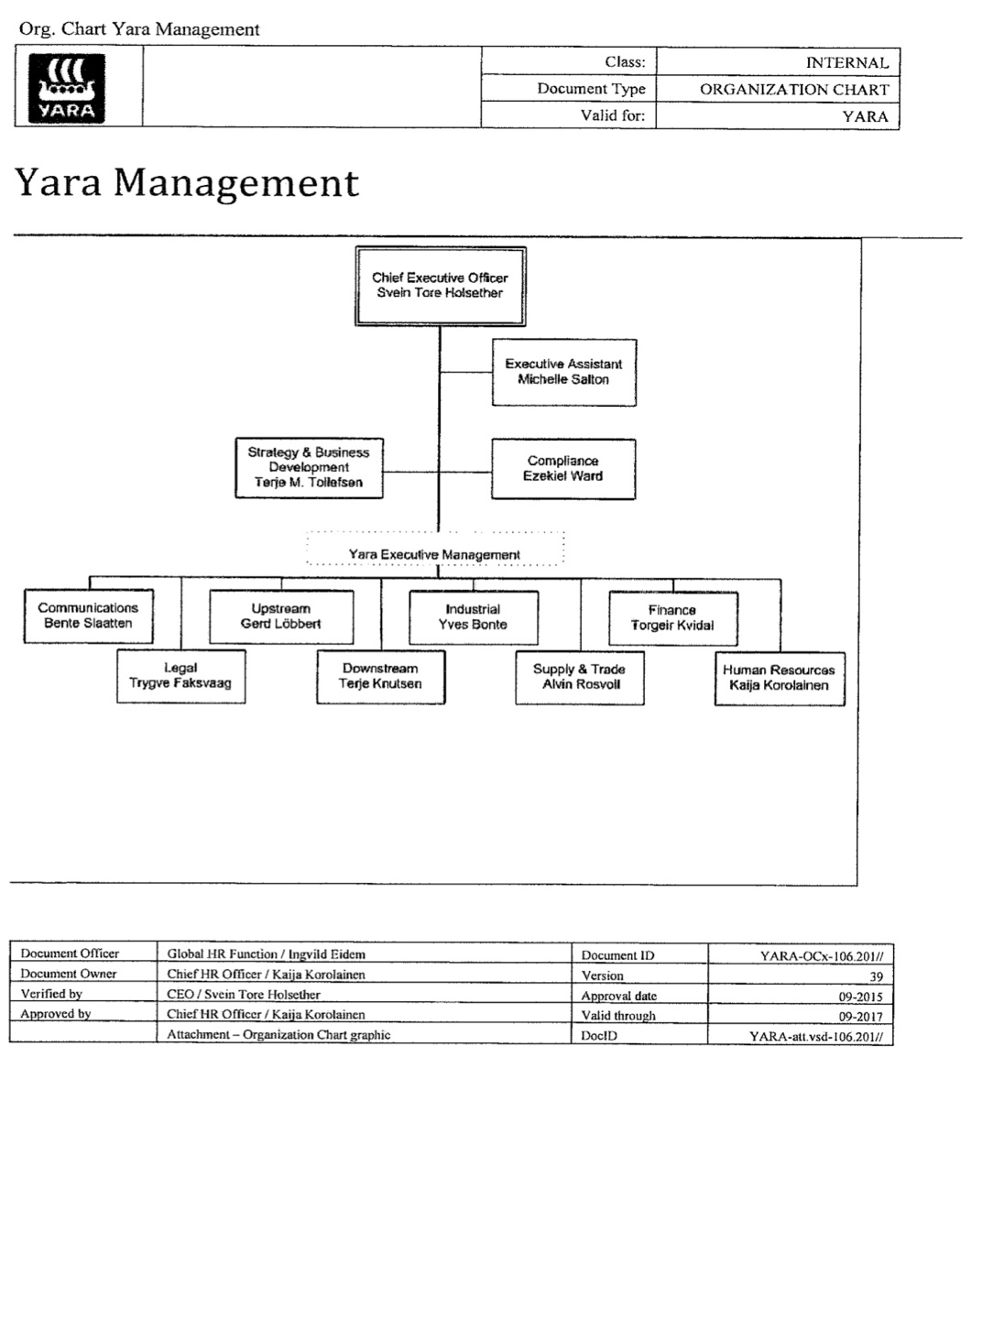

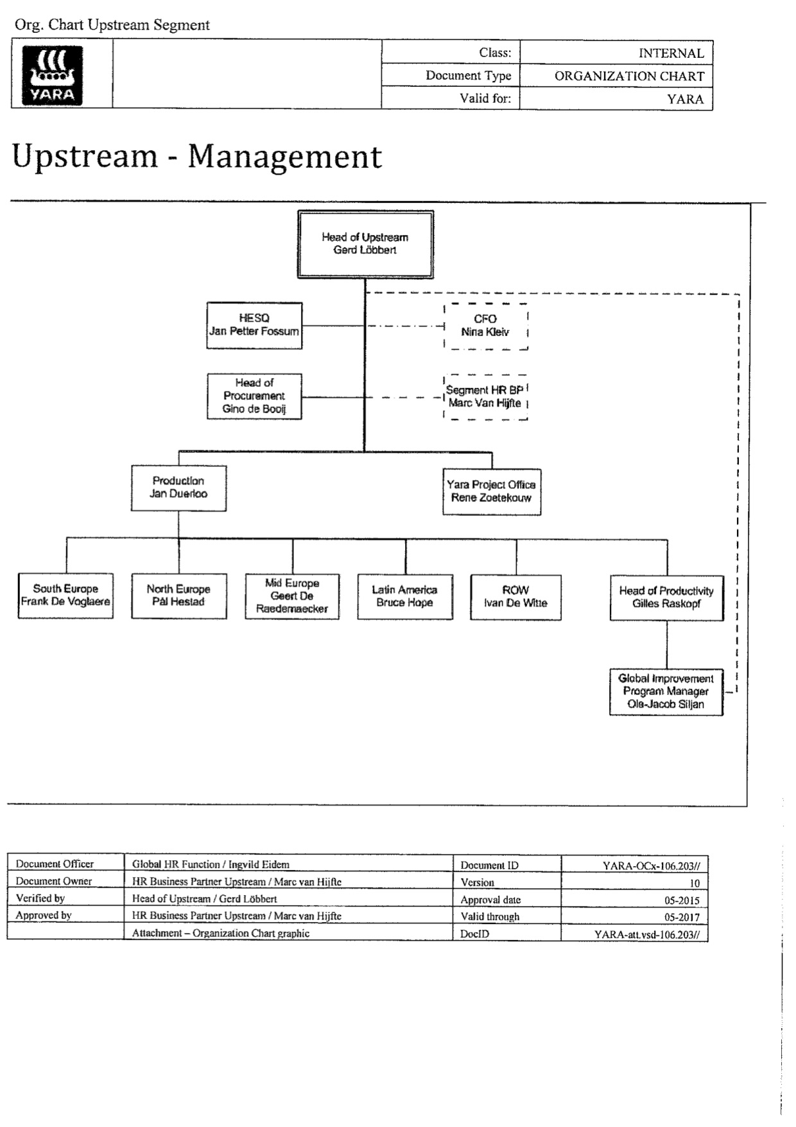

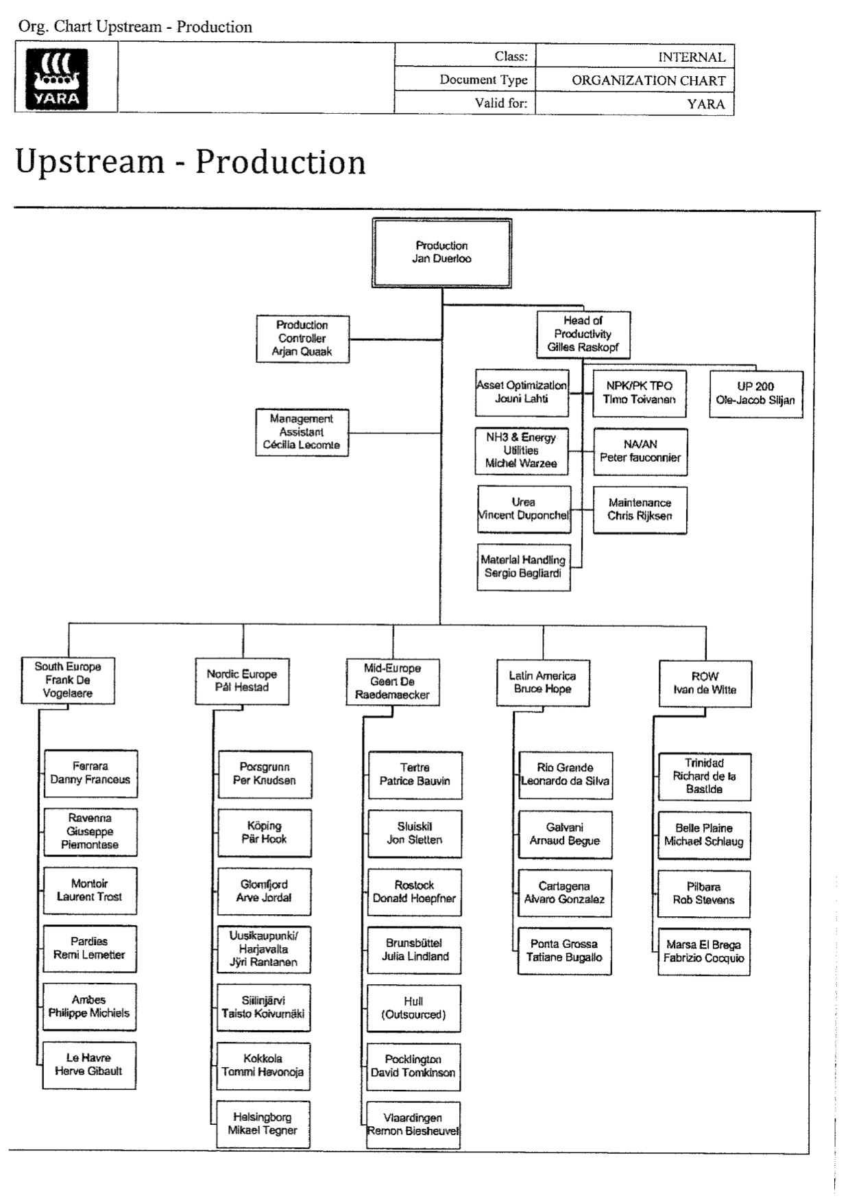

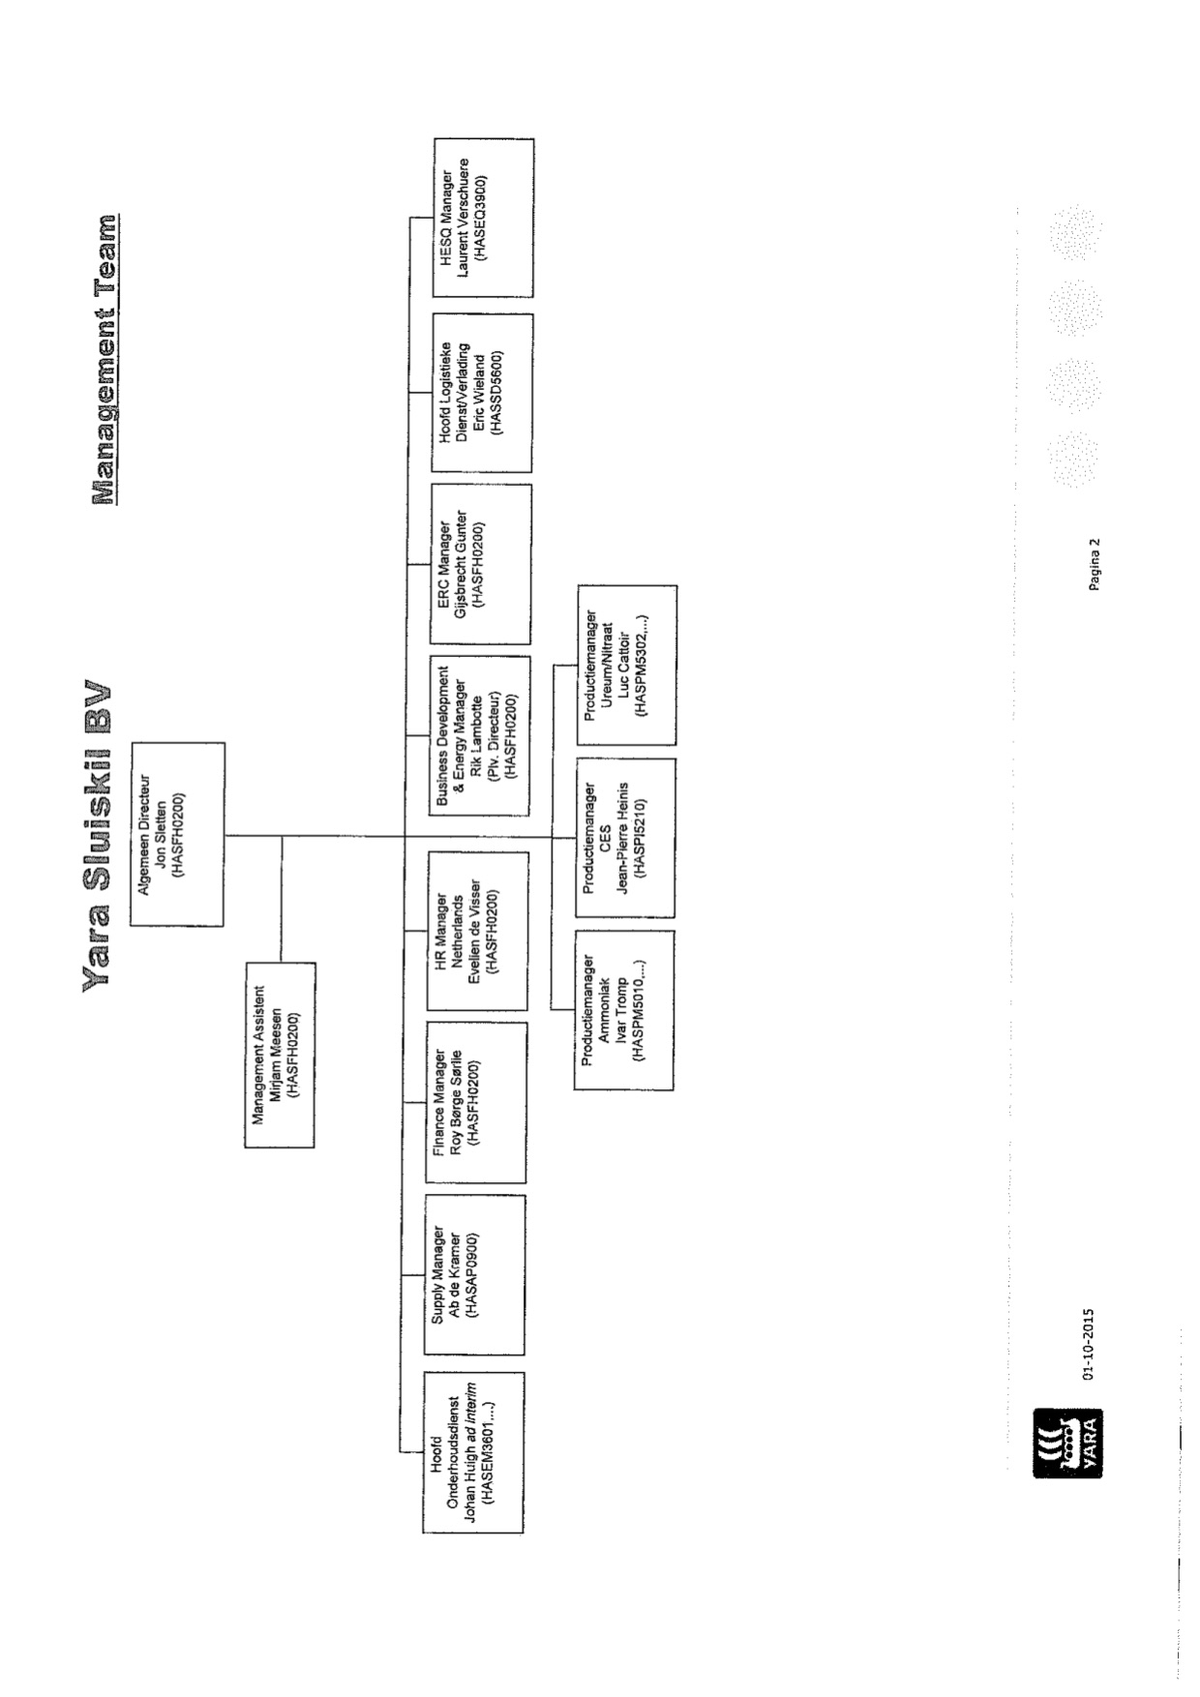

http://yara.com/about/history/our_history_at_a_glance/

