Task 2B Report of pitch at Axelle Springer

The report that interested us the most, was a wedding planner app called Vanolia (Vanolia, sd). The pitch was brought to us by a brother and a sister, who were experiencing troubles on weddings of their friends. It was really expensive to hire a wedding planner and to arrange the gifts, photos, etc. Therefore, the two founders, Pauline and Daniel launched the idea of Vanolia. This is an app for which you pay once, in a silver, gold or platinum package.
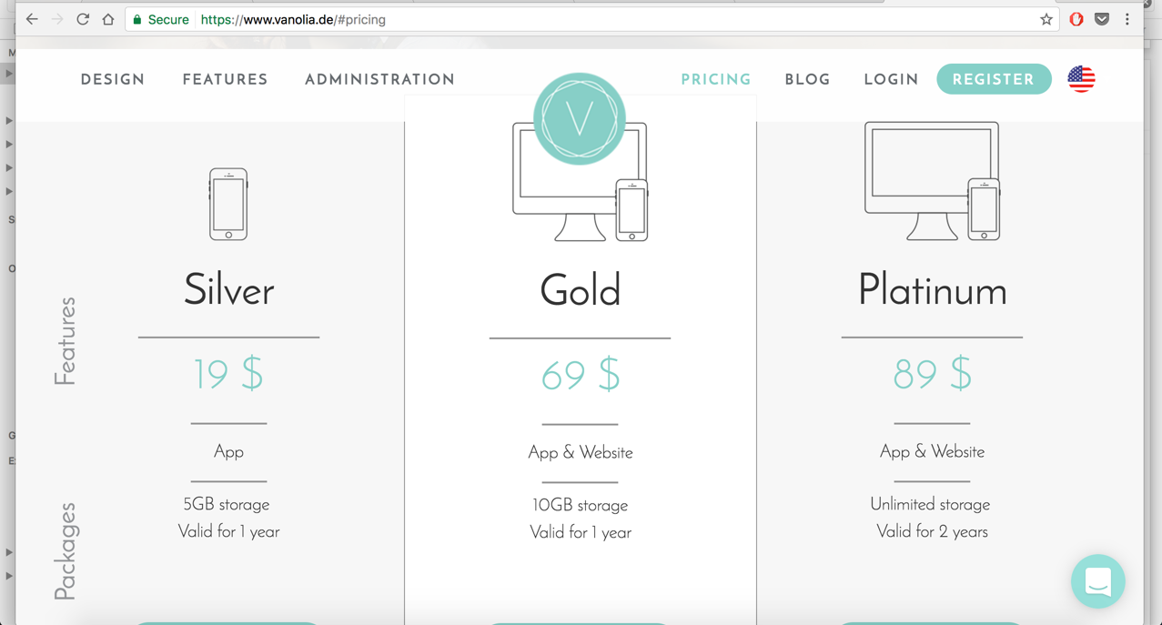

Figure 1: Printscreen of packages Vanolia (Vanolia, sd)
A wedding planner costs you about $100 per hour. If you use the app, people can share pictures, arrange to buy a gift together, manage RSVP’s, provide details about events (like fitting evenings for dresses etc.), accommodations and many more to come.

We think that this app is really helpful if you want to arrange your wedding and keep your guests entertained and have them looking forward to your wedding. During the pitch, they told us that they were also going to include a function in which you could let Vanolia send the invitations to the guests on paper as well as via the app. Also, the guests can ask questions to the couple via the app, which makes it easy for the couple to answer all of these.

We think that this idea is really simple, but really good. It does not cost a lot for company, but they can gain a solid revenue. If people use it on a wedding, they can use it for their own wedding and so on. The conversion is only once, normally, but it can reach other people really fast and easy.

Works Cited
Vanolia. (n.d.). Vanolia. Retrieved from Vanolia: www.vanolia.de

